# Java: Braces

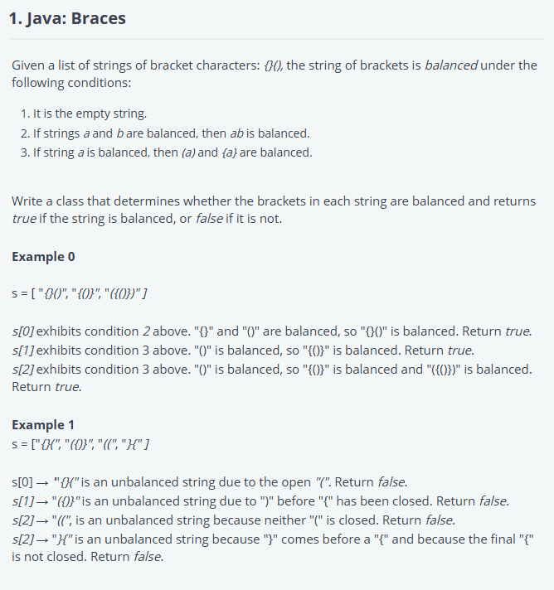

import java.util.*;

class Parser {

    static String isBalanced(String s) {

        Stack<Character> stack = new Stack<>();

        for (char c : s.toCharArray()) {

            if (c == '{' || c == '(') {

                stack.push(c); // Push opening brackets to the stack

            } else if (c == '}' || c == ')') {

                // Check if the stack is empty or the top does not match

                if (stack.isEmpty() || !isValidPair(stack.peek(), c)) {

                    return "false";

                }

                stack.pop(); // Pop the matched opening bracket

            }

        }

        // If stack is empty, it's balanced, otherwise not

        return stack.isEmpty() ? "true" : "false";

    }

    // Helper method to check if the pair of brackets are valid

    private static boolean isValidPair(char opening, char closing) {

        return (opening == '{' && closing == '}') || (opening == '(' && closing == ')');

    }

}

class Solution {

    public static void main(String[] args) {

        Parser parser = new Parser();

        Scanner in = new Scanner(System.in);

        while (in.hasNext()) {

            System.out.println(parser.isBalanced(in.next()));

        }

        in.close();

    }

}

# Java: Multi Sum

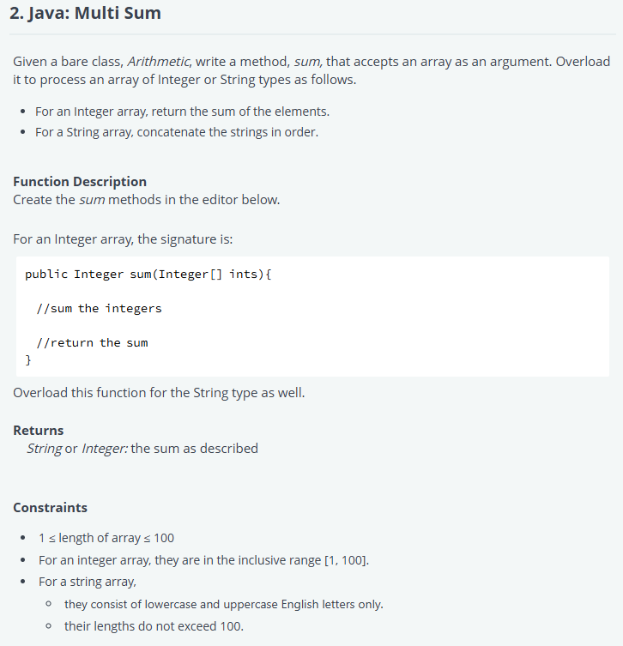

import java.io.*;

import java.util.*;

import java.text.*;

import java.math.*;

import java.util.regex.*;

class Arithmetic {

    // Method to sum Integer array

    public Integer sum(Integer[] ints) {

        int total = 0;

        for (Integer num : ints) {

            total += num;

        }

        return total;

    }

    // Method to concatenate String array

    public String sum(String[] strs) {

        StringBuilder result = new StringBuilder();

        for (String str : strs) {

            result.append(str);

        }

        return result.toString();

    }

}

public class Solution {

    public static void main(String args[] ) throws Exception {

        Arithmetic arithmetic = new Arithmetic();

        Scanner sc = new Scanner(System.in);

        String line = sc.nextLine();

        String[] values = line.split(" ");

        // check if it's an Integer array

        try {

            Integer.parseInt(values[0]);

            // Convert string array to Integer array

            Integer[] ia = new Integer[values.length];

            for (int i = 0; i < values.length; i++) {

                ia[i] = Integer.parseInt(values[i]);

            }

            // Call the sum method for Integer array

            System.out.println(arithmetic.sum(ia));

        } catch (NumberFormatException nfe) {

            // If it's not an Integer array, treat it as a String array

            // Call the sum method for String array

            System.out.println(arithmetic.sum(values));

        }

    }

}

# Java: Static Analysis

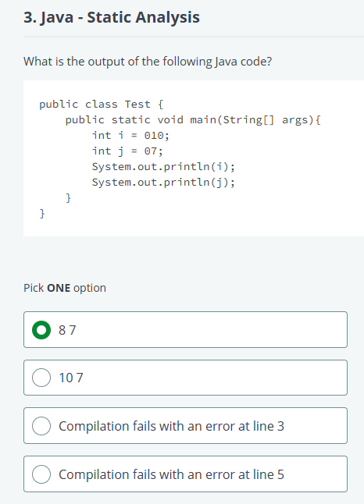

# Value After Bitmask

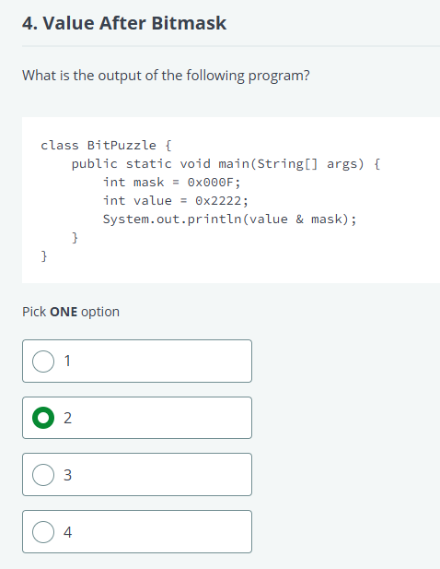

# Which of the following is not a correct way of commenting?

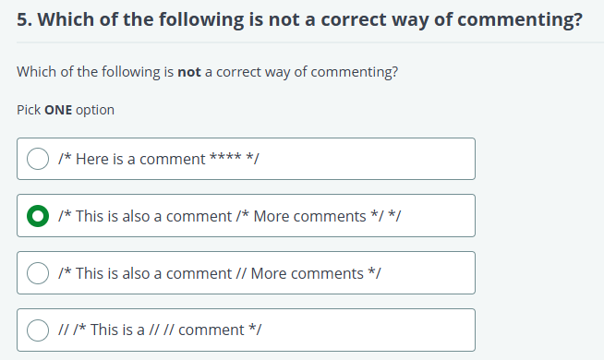

# Java: Threads – Static Analysis

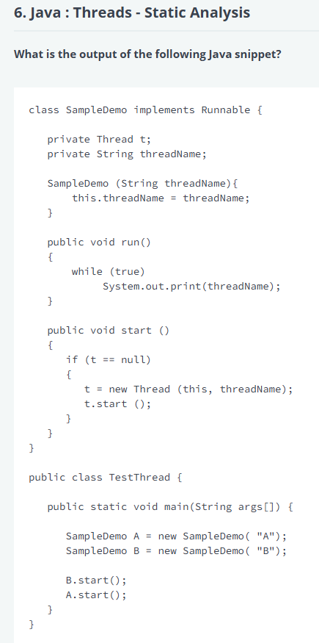

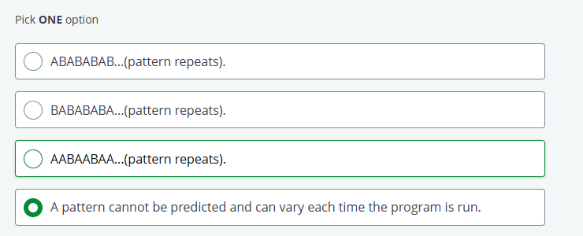

# Java: The Adder Class

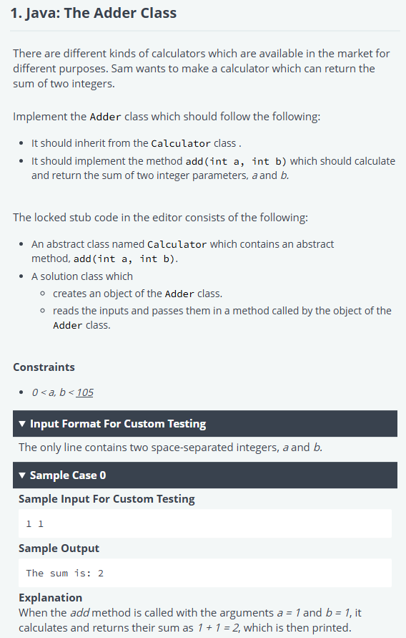

import java.util.Scanner;

abstract class Calculator {

    abstract int add(int a, int b);

}

// Adder class inherits from Calculator and implements the add method

class Adder extends Calculator {

    @Override

    public int add(int a, int b) {

        return a + b; // returns the sum of a and b

    }

}

public class Solution {

    public static void main(String[] args) {

        int a, b;

        try (Scanner scan = new Scanner(System.in)) {

            a = scan.nextInt();

            b = scan.nextInt();

        }

        // Create an object of Adder and call the add method

        Calculator adderObject = new Adder();

        System.out.println("The sum is: " + adderObject.add(a, b));

    }

}

# Java: Type Counter

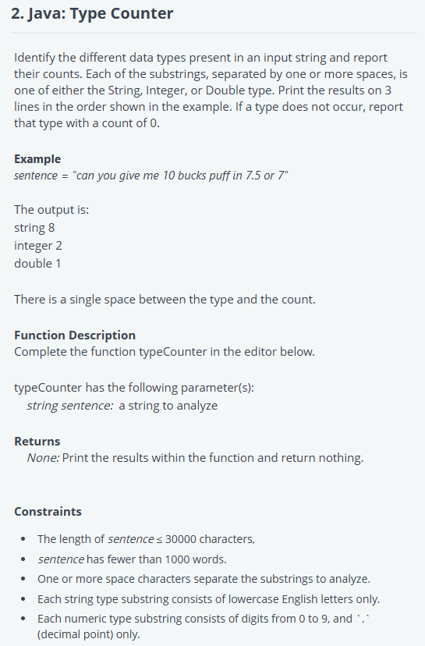

# Java Print a Sum

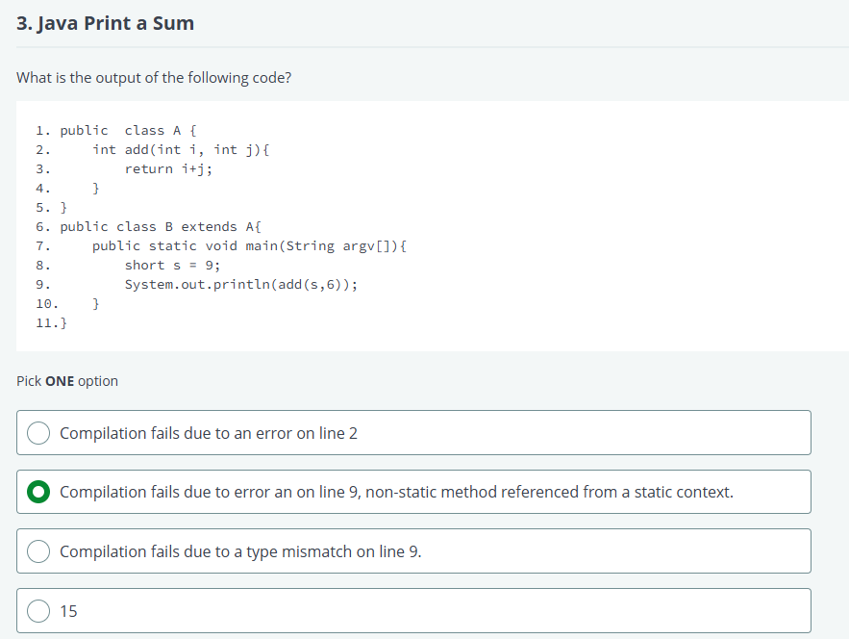

# The Map Interface

# Static Code Analysis 5

# Return Type

